

**BOOTCAMP DATA ANALYSIS**

**PATRICIO AUGUSTO PATIÑO ESPAÑA**

**CHALLENGE MODULE4**

**PyCity School Analysis**

**WRITTEN REPORT**

**July 4th, 2024**

Objective:

Analyze the data we get from the PyCitySchools.jpynb from the csv’s schools\_complete and student\_complete.

**Data**

**General Data**

The first data we get:

* Schools: 15
* Students: 39,170
* Budget: $24,649,428
* Average Math Score: 78.99
* Average Reading Score: 81.88
* Percentage Passing Math: 74.98%
* Percentage Passing Reading: 85.81%
* Overall Passing Rate: 65.17%

**School Summary**

Now we are going to analyze per school:

School with more students: Bailey High School

School with less students: Holden High School

School with more Budget: Bailey High School with $3,124,928

School with less Budget: Holden High School with $248,087

School with more Budget per capita: Huang High School with $655.00

School with less Budget per capita: Wilson High School with $578.00

School with more average math score: Pena High School with 83.84

School with less average math score: Huang High School with 76.63

School with more average reading score: Pena High School with 84.04

School with less average reading score: Ford High School with 80.74

School with more passing math rate: Pena High School 94.59%

School with less passing math rate: Huang High School 65.68%

School with more passing reading rate: Thomas High School 97.31%

School with less passing reading rate: Ford High School 79.30%

School with more passing overall rate: Cabrera High School 91.33%

School with less passing overall rate: Rodriguez High School 52.99%

With this, we can say that the school with more students is **Bailey High School**, and the school with less students is **Holden High School**, and the school with more budget and more budget per capita is **Huang High School**, and the les budget is **Holden High School**, that agrees that is the school with less students, but the school with less budget per capita is **Wilson High School**.

The **Pena High School** is the school with more average in math and reading score and more passing math rate, the **Huang High School** has the less average math score, and the **Ford High School** has the less average reading pass. The **Thomas High School** has more passing reading rate, and the **Cabrera High School** has the more passing overall rate. The **Huang High School** has the less passing math rate that agrees that has the less average math score, the **Ford High School** has the less passing reading rate, and the **Rodriguez High School** has the less passing overall rate.

With this we can say that Pena High School has the best average in math and reading, so is one of the best schools, and the Huang High School that has the best budget and the best budget per capita, have the less average math score, and the less passing math rate, so more budget doesn’t mean better averages.

**% Overall Passing**

|  |  |
| --- | --- |
| **Highest-Performing** | **Bottom-Performing** |
| Cabrera High School | Rodriguez High School |
| Thomas High School | Figueroa High School |
| Griffin High School | Huang High School |
| Wilson High School | Hernandez High School |
| Pena High School | Johnson High School |

In this chart we can see that the school with the best Percentage Overall Passing is the Cabrera High School, and the school with the less Percentage Overall Passing is the Johnson High School. In this case the Pena High School that has the best average in math and reading, it doesn’t has the best Percentage Overall because the school is the second one with less students.

**Scores by Grade**

|  |  |  |  |  |
| --- | --- | --- | --- | --- |
| **Math Score** | | | | |
|  | **9th** | **10th** | **11th** | **12th** |
| **Best Score** | Holden | Griffin | Holden | Pena |
| **Worst Score** | Rodriguez | Figueroa | Rodriguez | Ford |

|  |  |  |  |  |
| --- | --- | --- | --- | --- |
| **Reading Score** | | | | |
|  | **9th** | **10th** | **11th** | **12th** |
| **Best Score** | Shelton | Thomas | Shelton | Holden |
| **Worst Score** | Ford | Rodriguez | Ford | Huang |

With these scores by grade, we can visualize that we have different schools in the chart, for the best and the worst scores, analyzing these scores by grade we have a better visualization of the scores.

**Spending Ranges (Per Student)**

**School <$585**

* Cabrera High School
* Holden High School
* Wilson High School
* Wright High School

**School $585-$630**

* Bailey High School
* Griffin High School
* Pena High School
* Shelton High School

**School $630-$645**

* Figueroa High School
* Ford High School
* Rodriguez High School
* Thomas High School

**School $645-$680**

* Hernandez High School
* Huang High School
* Johnson High School

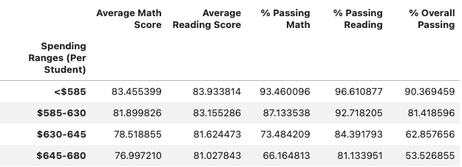

In this chart we can visualize the average math and reading score, and the percentage passing math and reading, and the percentage overall passing. Now that we know wich schools are in the range of each spending range (Per Student), we can visualize that the schools with less spending ranges (Per Student) have the best average in both, math and reading, also the best percentage passing math and reading and the best percentage overall passing. And the schools that have more spending Ranges (Per Students) have the worst average in math and reading, also the worst percentage passing math and reading, and percentage overall passing. So, in this case we can say that when they have more money, the worst are the grades they have, and the schools that have less money, have the best scores.

**Scores by School Size**

**Small <1000**

* Holden High School
* Pena High School

**Medium 1000-2000**

* Cabrera High School
* Griffin High School
* Shelton High School
* Thomas High School
* Wright High School

**Large 2000-5000**

* Bailey High School
* Figueroa High School
* Ford High School
* Hernandez High School
* Huang High School
* Johnson High School
* Rodriguez High School
* **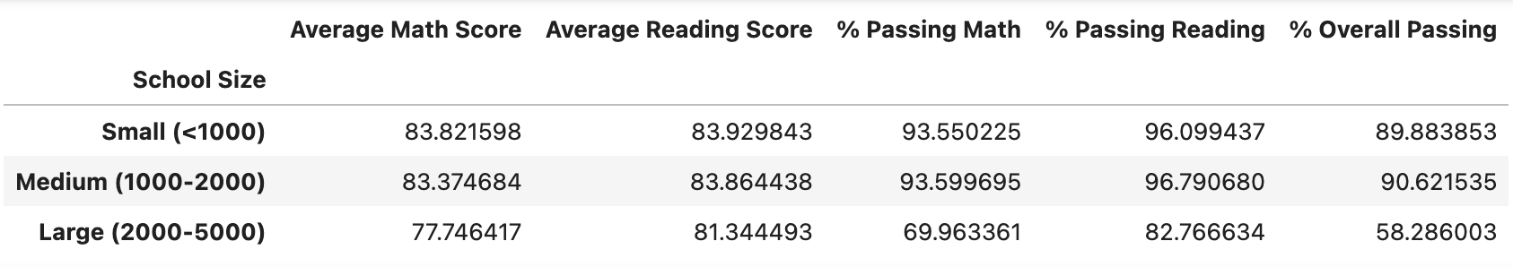**Wilson High School

In this chart we can visualize the average math and reading score, and the percentage passing math and reading, also the percentage overall passing, and we are going to analyze this per school size. In this chart we can see that the school who have better grades are the medium schools, and the small schools are not so far with the grades. But the large schools have the worst grades of all.

**Scores by School Type**

**Charter**

* Shelton High School
* Griffin High School
* Wilson High School
* Cabrera High School
* Holden High School
* Pena High School
* Wright High School
* Thomas High School

**District**

* Huang High School
* Figueroa High School
* Hernandez High School
* Bailey High School
* Rodriguez High School
* Johnson High School
* Ford High School

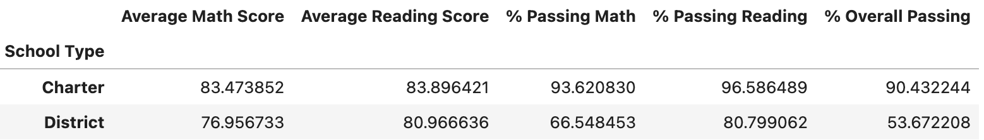

In this charter we are going to analyze the average math and reading score, the percentage passing math and reading, and the percentage overall passing per school Type. So, the best scores are for the Charter Schools, and the worst scores are for District Schools.

**Analysis**

With the data we obtain, we can say that:

The best scores obtain by the students are for the schools that:

* Have the less budget
* Have the less budget per capita
* Have the less spending rate per student
* Have small size
* Are Charter’s School

The worst scores obtain by the students are for the schools that:

* Have more budget
* Have more budget per capita
* Have more spending rate per student
* Have large size
* Are District School’s

So, we can say that all the data that we get, agrees with the results obtains, that the best scores are for schools like: **Pena High School**, **Thomas High School** and **Cabrera High School**, that meet all the criteria. Also, the worst scores are for schools like: **Huang High School** and **Ford High School** that also meet all the criteria.

To sum up, although this school has less budget and less spending rate per student, but the fact that they have fewer students, helps students to have better learning and better performance, contrary to the schools who have more budget, more spending rate per student and more students per schools have a lower performance.

Schools that have better averages, with more budget can achieve better averages, and schools that have lower averages, with the budget they have, must be able to improve the averages of their students, this can be achieved by reducing their groups of students, because as we already saw, the fewer students, the better the averages.

Resources:

Data generated by [Mockaroo, LLCLinks to an external site.](https://mockaroo.com/" \t "_blank), (2022). Realistic Data Generator. Data for this dataset was generated by edX Boot Camps LLC, and is intended for educational purposes only.